Software Engineering Tools Lab

**Assignment no. 8**

Name: Gopal Shendge

PRN: 2020BTECS000061

* 1. What are the prerequisites for installing the TestLink tool.

*Ans:*

Testlink requires these programs:

* + 1. MySQL 4.0.x
    2. php 4.3.x
    3. Webserver (Apache 1.3.x or 2.0.x and higher, IIS 3 and higher, etc.)
  1. Install TestLink tool on your machine (Provide screen shots for successful installation and login)

*Ans:*

* + 1. Make sure that all the prerequisites mentioned above are satisfied.
    2. Start the ‘Apache’ & ‘MySQL’ service using XAMPP control panel.
    3. Go to <https://sourceforge.net/projects/testlink/> and click Download.
    4. Now unzip the downloaded .zip file and rename the folder name as TestLink.
    5. Go to XAMPP folder and navigate to htdocs folder. Place the TestLink folder there.
    6. Go to TestLink package and open “config.inc.php” file, update:

$tlCfg→log_path = 'E:/XAMPP/htdocs/TestLink/logs/';

$g_repositoryPath = 'E:/XAMPP/htdocs/TestLink/upload_area/';

* + 1. Now open a browser and type <http://localhost/Testlink> in the navigation bar and press Enter. It will display the installation page of TestLink.
    2. Click New Installation.
    3. Check the checkbox for Terms and Conditions and click the Continue button.

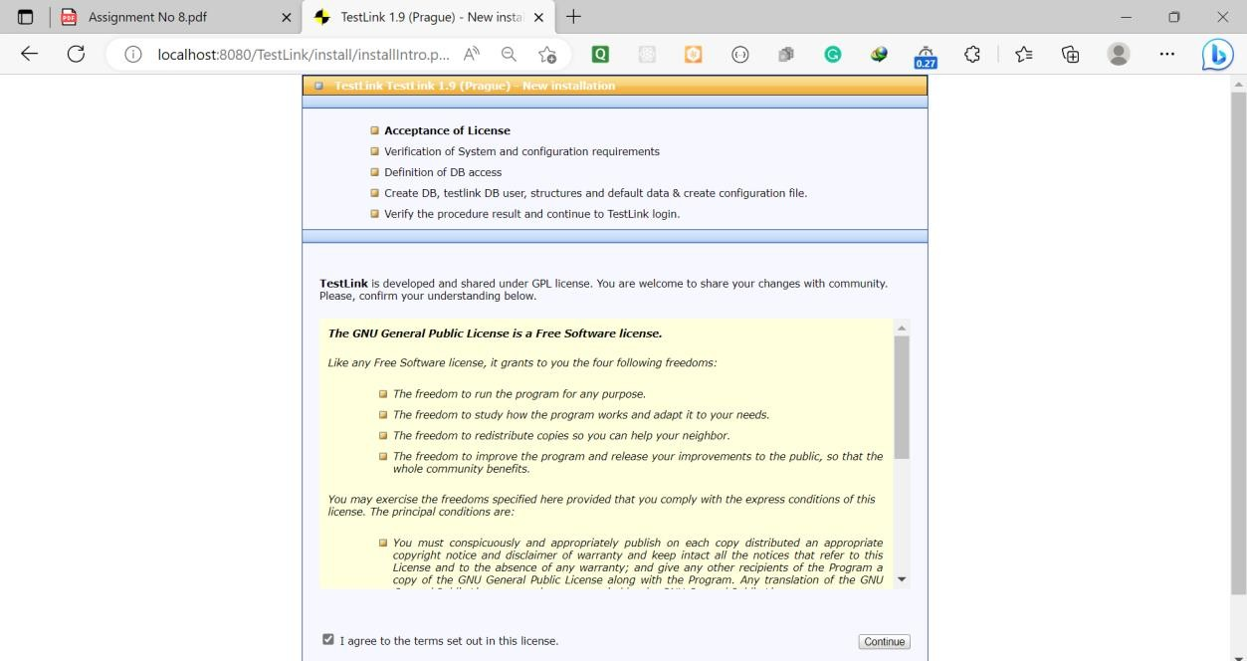

* + 1. Check the

checkbox for Terms and Conditions and click the Continue button. The system will check the pre-requisites to ensure everything is fine. A Continue button will appear at the bottom, otherwise an error message will be displayed.

* + 1. Click

Continue.

* + 1. In the next step,

Database Admin and Admin password is required to define MySQL access. TestLink admin username/password can be anything given by the user.

* + 1. Click “Process

TestLink Setup” button. You should see the TestLink “Installation was successful!” message being displayed.

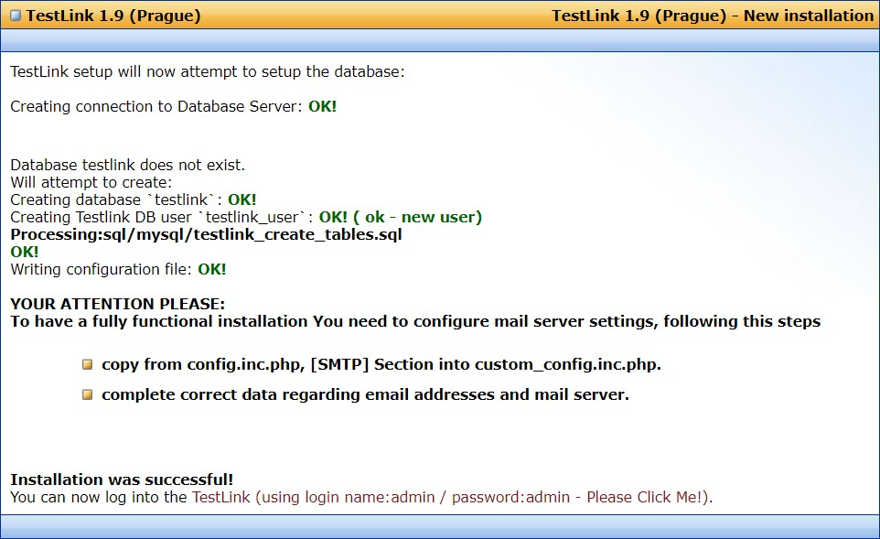

* + 1. Now again

navigate to <http://localhost/testlink>. You will see the login page.

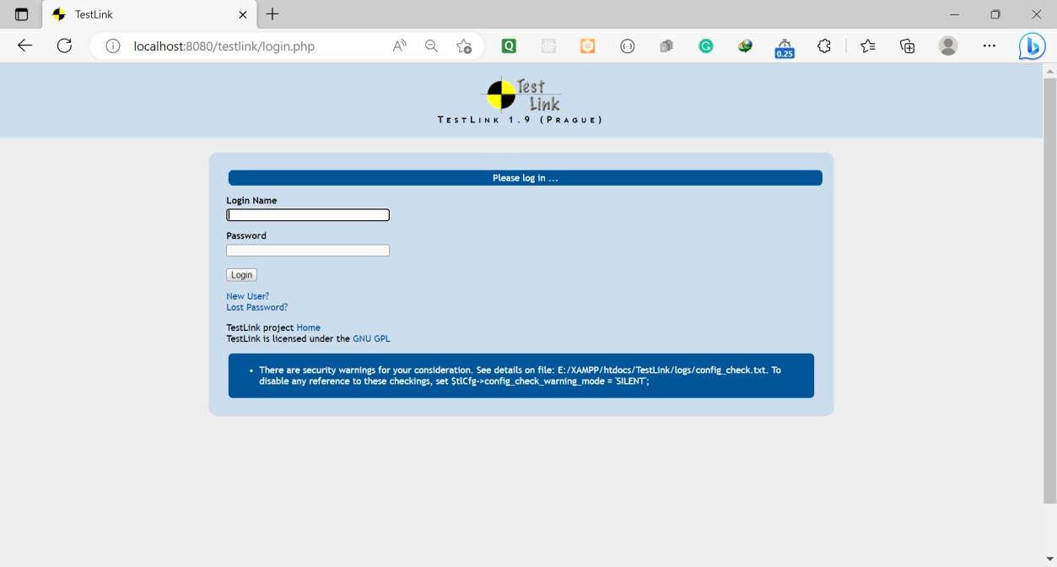

* 1. Using TestLink tool create multiple test cases (at least 10) on any application/project that you have implemented.

Perform below tasks:

1. Create New test project as SETProject
2. Create a test plan as SETProjectTestPlan
3. Create a build as SETProjectBuild
4. Create test suite as Test Suite 1 under SETProject
5. Create Test cases in TestLink Tool
6. Assign created Test Cases to the test plan SETProjectTestPlan
7. Create different roles as given below in the TestLink

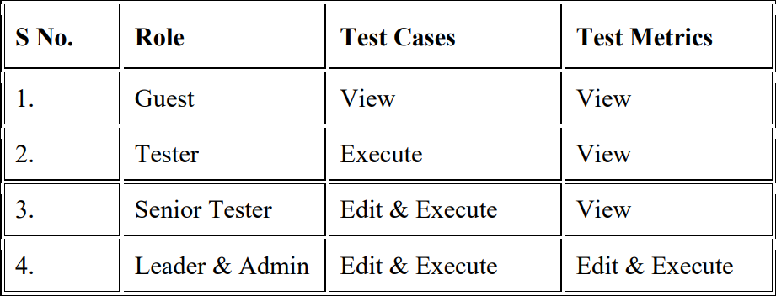

1. Write a requirements in TestLink
2. Execute test cases
3. Generate a test report in excel format

*Ans:*

* 1. Create New test project as SETProject

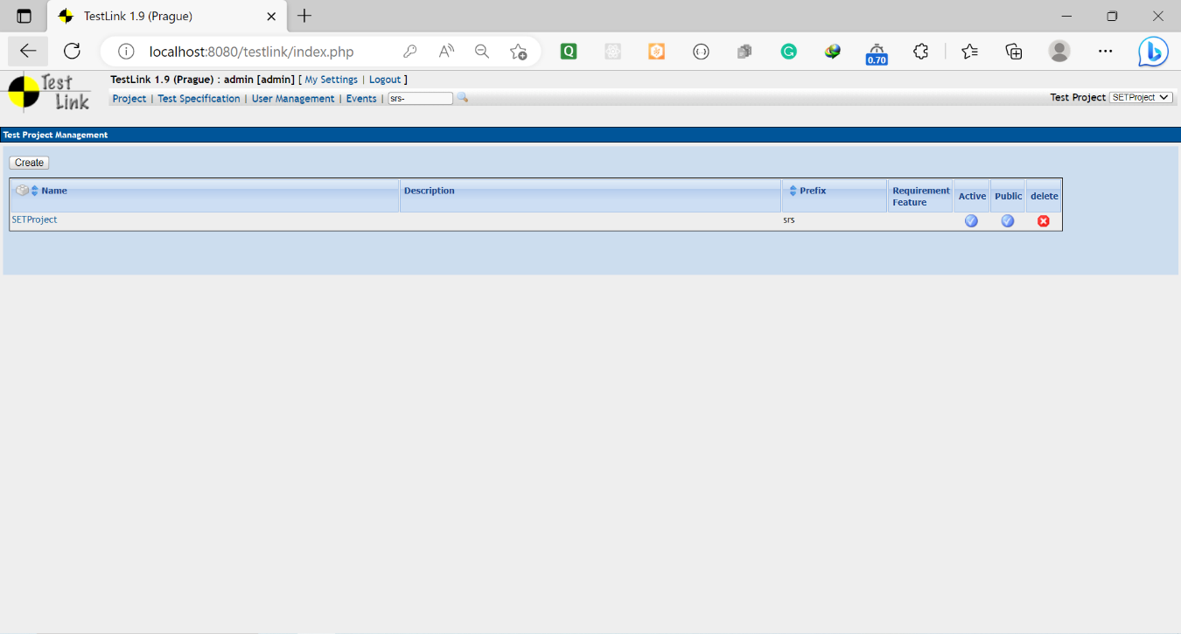

* 1. Create a test plan as SETProjectTestPlan

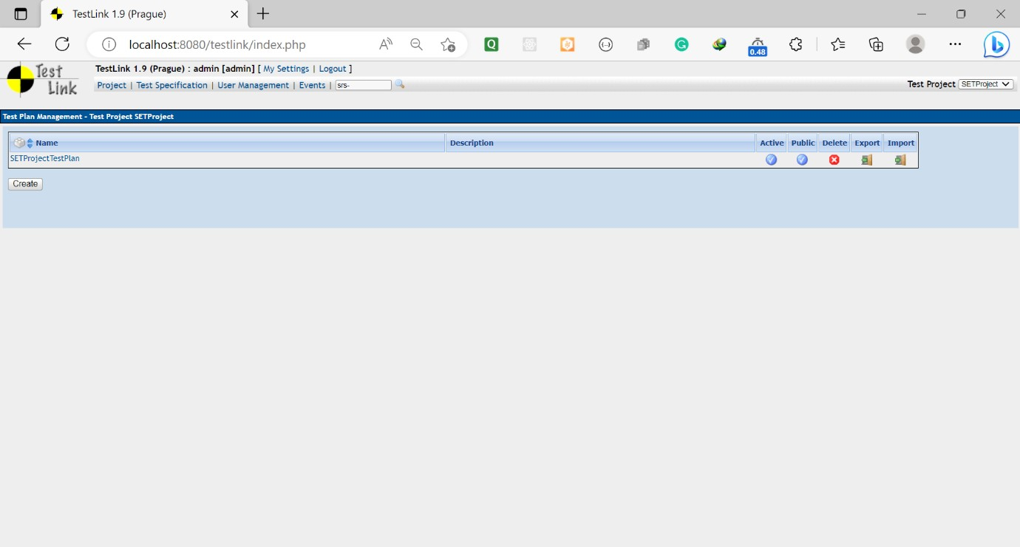

* 1. Create a build as SETProjectBuild
  2. Create test suite as Test Suite 1 under SETProject

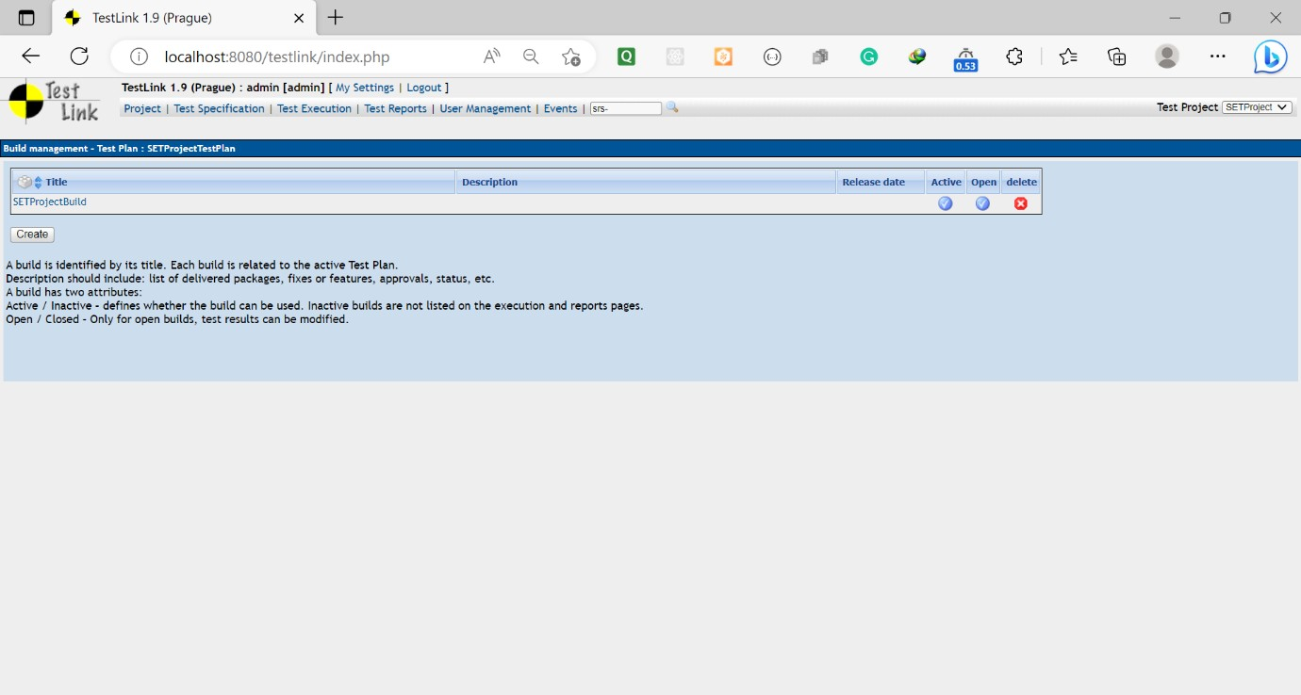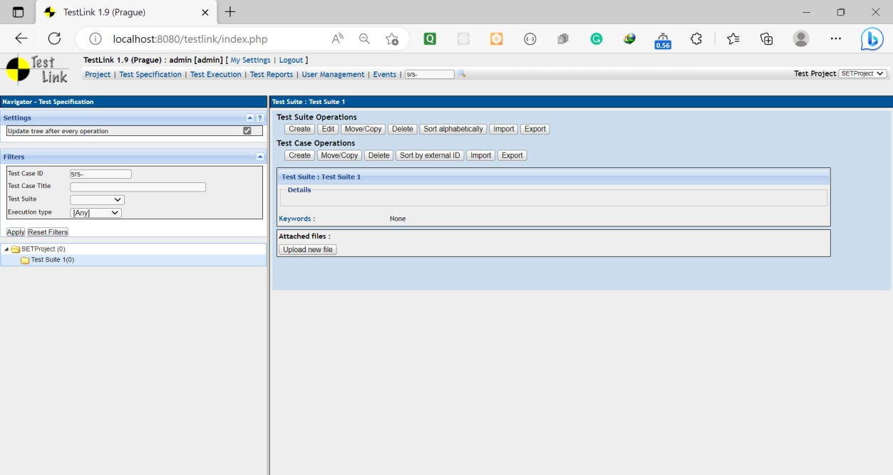

* 1. Create Test cases in TestLink Tool
  2. Assign created Test Cases to the test plan SETProjectTestPlan

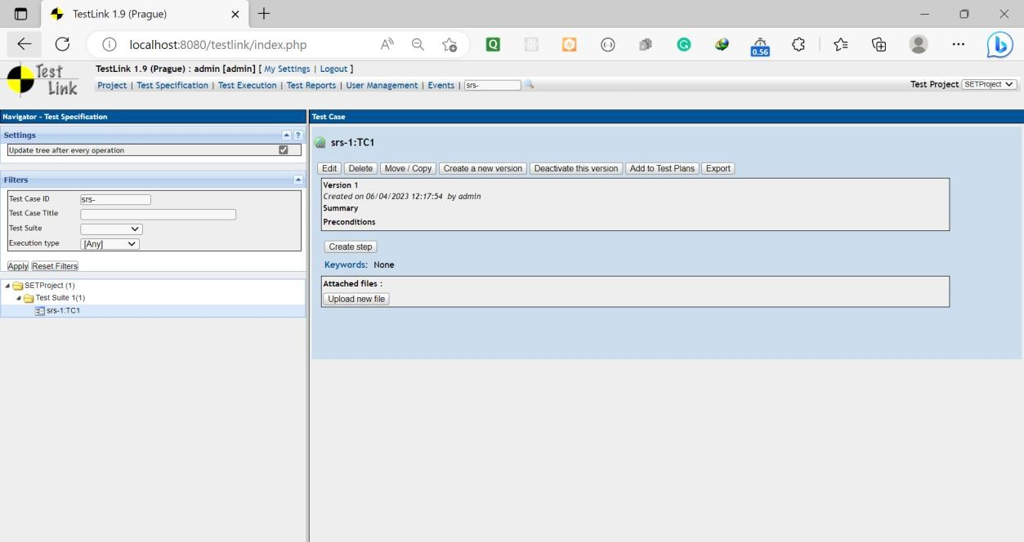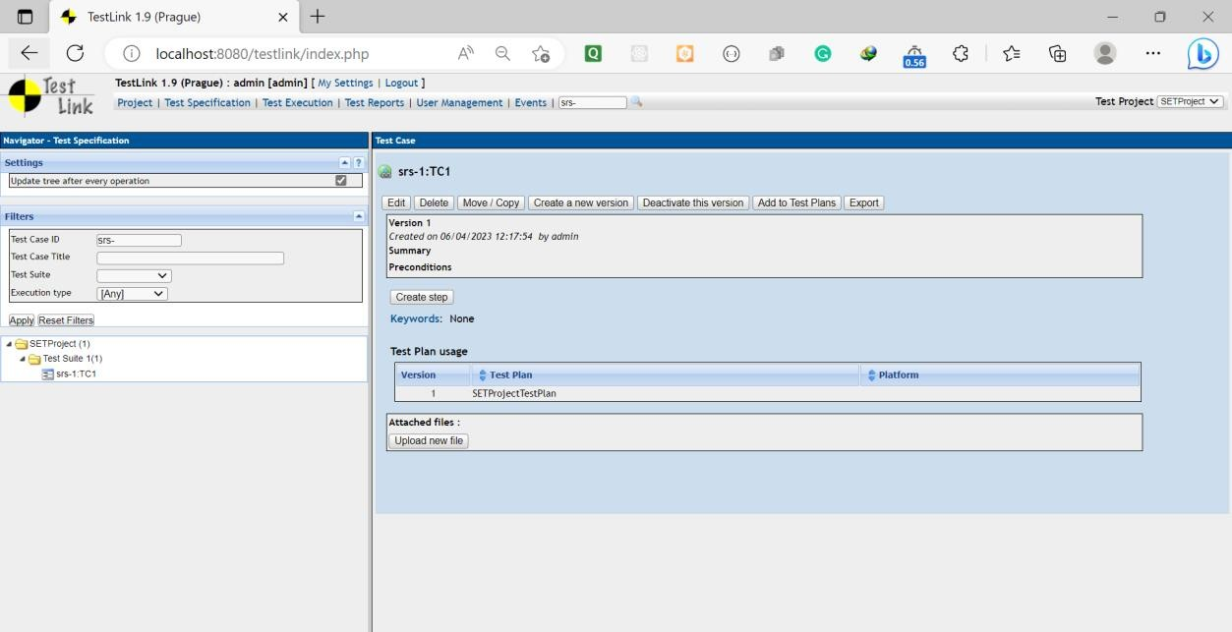

* 1. Create different roles as given below in the TestLink



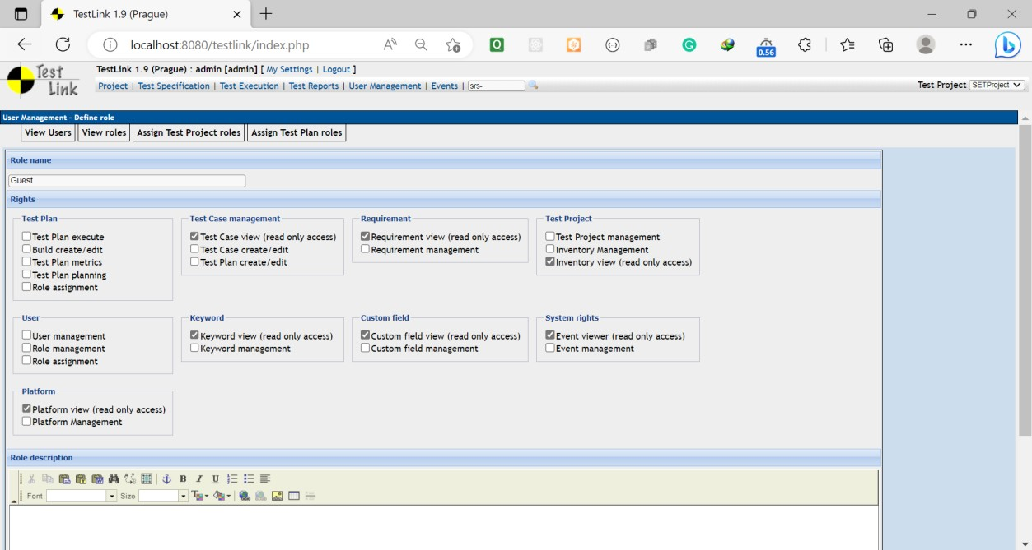

* + 1. Guest:
    2. Tester:

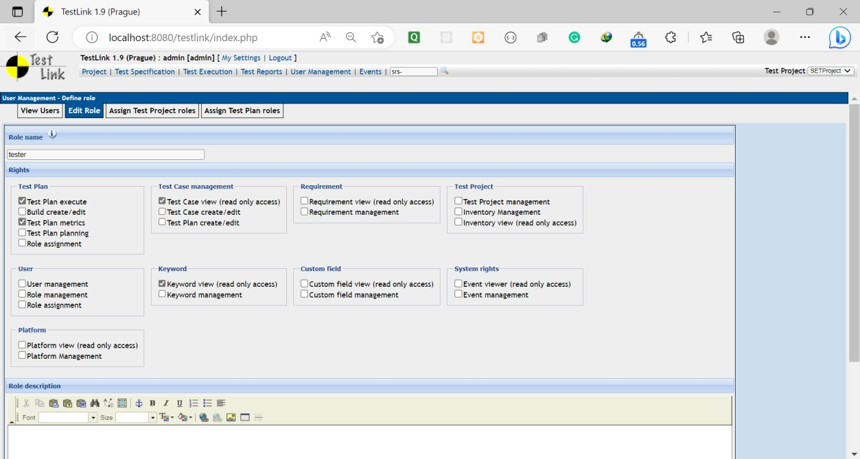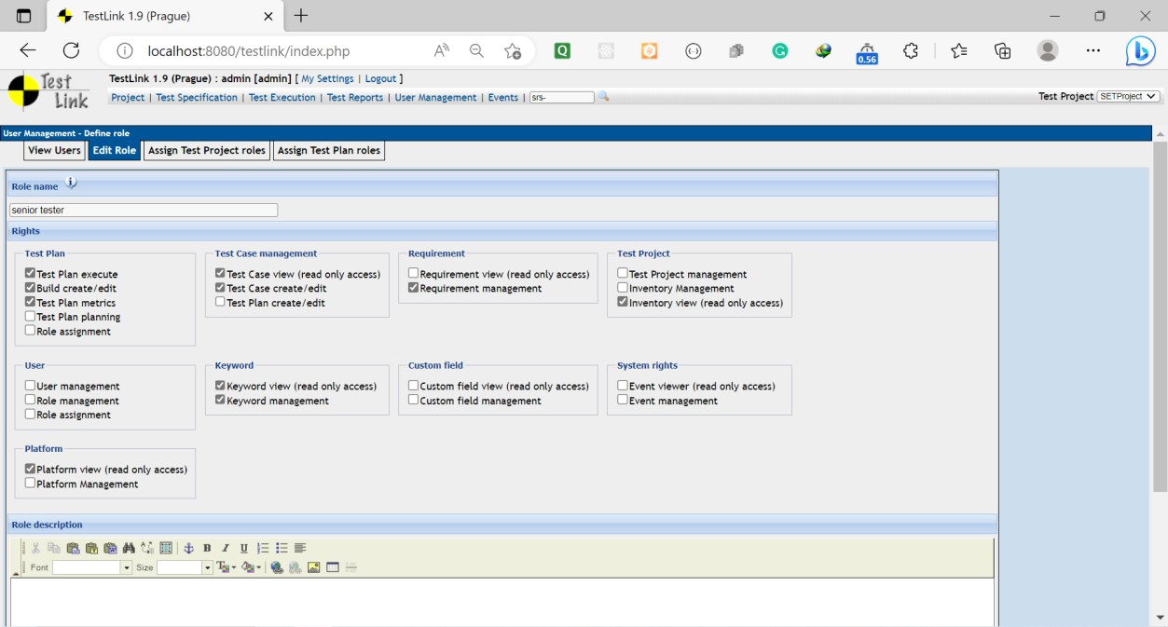

* + 1. Senior Tester:
    2. Leader & Admin:

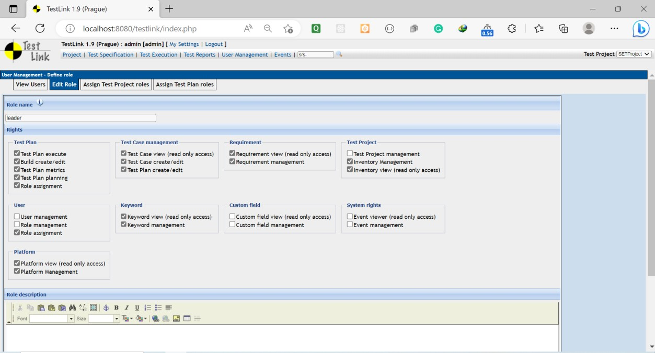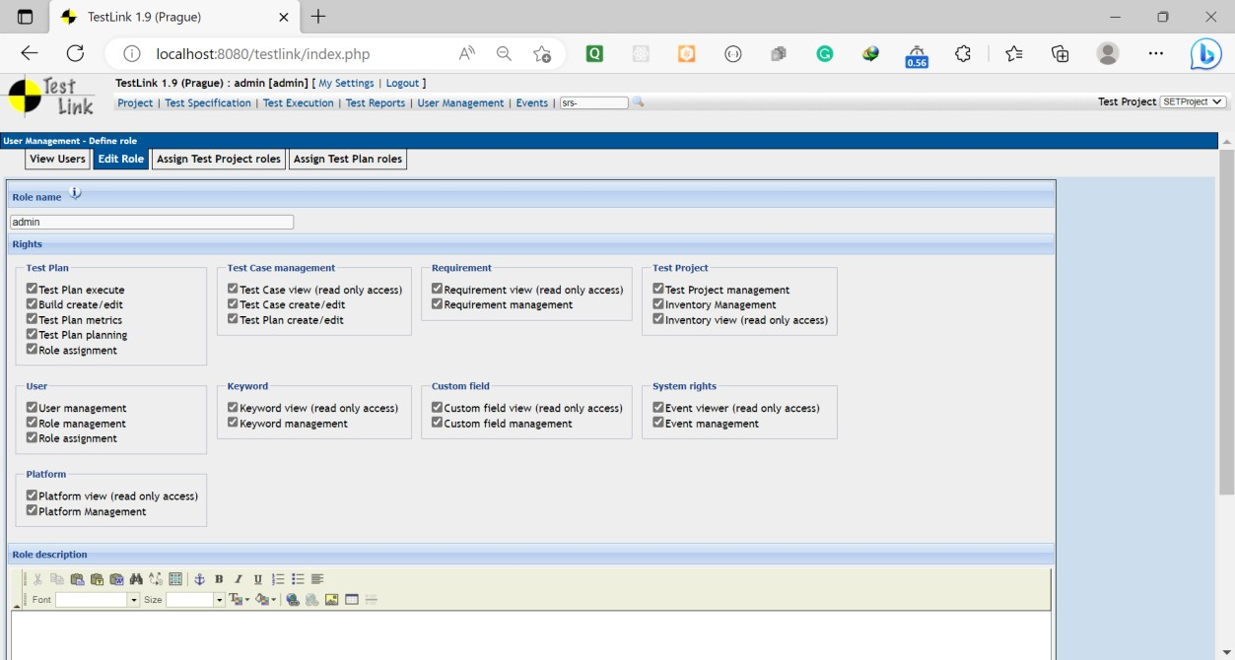

* 1. Write a requirements in TestLink
  2. Execute test cases
  3. Generate a test report in excel format

